**Reference points for 6a, 7bc herring**

**Martin Pastoors1**

16/03/2019 18:03

[ All the codes to generate this section of the report are in *refpts her6a7bc.Rmd* on the wgHAWG github page]

Biological reference points using the development version of ICES MSY package (v.0.1.18) and EQSIM method, applied to the final assessment of the Interbenchmark 2019. The new assessment provides a very different perception of stock trends and the stock recruitment relationship compared to the most recent accepted assessment (HAWG 2018), notably because the most recent years have now been estimated to have been with low SSB and low recruitment, whereas before the low recruitments where thought to be with higher SSB.

Because the final assessment is a multifleet assessment, the methode *collapseFleets* has been applied to collapse the multifleet object into a single fleet object that can be used in EQSIM.

The reference points as estimated in WKWEST 2015, and used by ACOM since then, are as follows

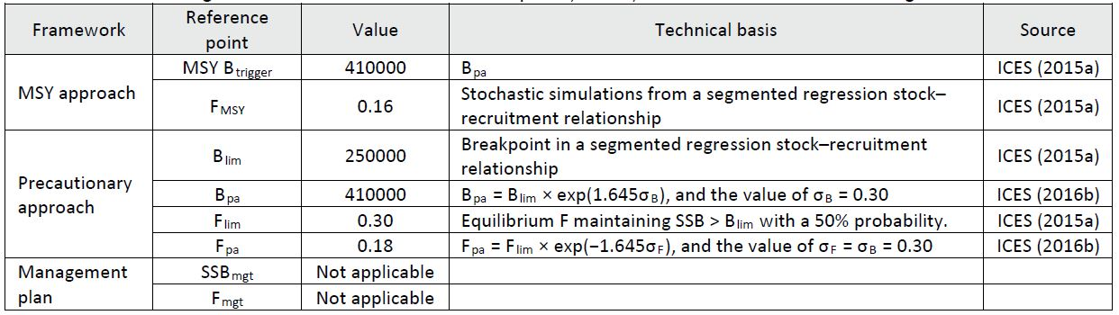

The stock trends of the IBP assessment show that the recruitment and stock have been very high in the period 1960-1970. At the same time there is substantial uncertainty about the data for the period. Given that these high SSB-high recruitment period has a large impact on the estimated stock and recruitment pairs, two separate analysis have been carried out: one using the whole time-series and one using a time-series from 1975 onwards.

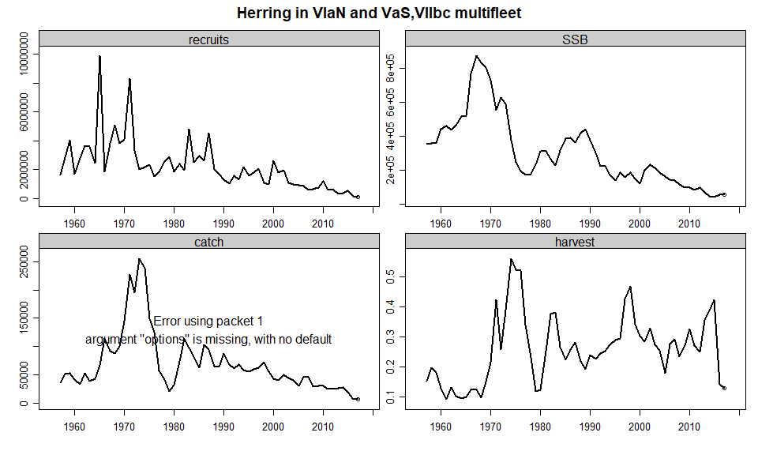

[ I will put in a figure comparing this assessment with the last accepted assessment ]

This change in perception of SSB and recruitment had a profound effect on the breakpoints estimated by the segmented regression analysis. Below is the (smoothed) segmented regression from the WKWEST report and below that is the segmented regression from the IBP final assessment using the whole time series and using the shortened time series (1975 onwards). The estimated breakpoints in the IBP assessment have experienced a strong shift to the right (i.e. at higher SSB).

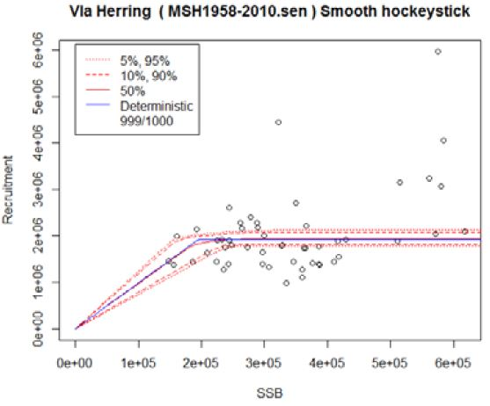

Settings used for the EQSIM analysis. Fcv and Fphi were derived from *HER 6a7bc Fcv and phi.xlsx*.

---------------------- -----------  
**nsamp** 2000   
**bio.years** 2008-2017   
**bio.const** FALSE   
**sel.years** 2008-2017   
**sel.const** FALSE   
**recruitment.trim** 3--3   
**Fcv** 0.3   
**Fphi** 0.37   
**verbose** FALSE   
**extreme.trim** 0.01-0.99   
**Nrun** 200   
**rshift** 1   
---------------------- -----------

Following the accepted procedure for estimating reference points, several reference points could not be estimated (Fp05, MSY Btrigger) because of lack of convergence. This is probably due to the current low stock size and the high Blim. An overview of the calculated reference points (absolute and relative) are in the text tables below.

Flim Fpa Fmsy Fp05 Blim Bpa MSYBtrigger  
1 0.14 0.11 0.08 0.12 220000 290000 6e+05

Flim Fpa Fmsy Fp05 Blim Bpa MSYBtrigger  
1 0.54 0.42 0.31 0.46 0.31 0.41 0.85

Shortening the time series to 1975 made significant differences to the reference points so they are highly dependent on the length of the time series. An overview of the calculated reference points (absolute and relative) for the short time series are in the text tables below.

Flim Fpa Fmsy Fp05 Blim Bpa MSYBtrigger  
1 0.12 0.09 0.03 0.03 220000 290000 4e+05

Flim Fpa Fmsy Fp05 Blim Bpa MSYBtrigger  
1 0.42 0.31 0.1 0.1 0.46 0.61 0.84

**Conclusion**

IBPHer6a7bc concluded that after a considerable amount of work being carried out within the interbenchmark and given all the uncertainties and the inability to estimate several reference point, we propose not to present any reference points for 6a, 7bc herring. It is anticipated that a full benchmark will be carried out within a few years which will be able to split the two stocks into separate assessments. That would also be the time to revisit the estimation of reference points.